1.Historgams

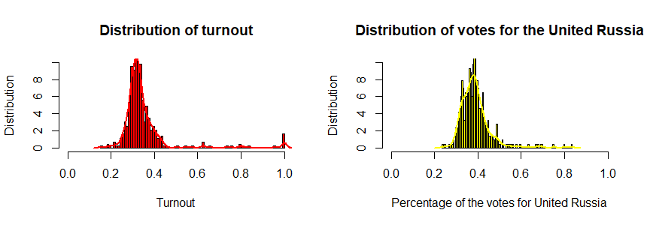

2.Boxplots

3. Plot showing the dependence of the results of all 14 party lists from the turnout

6.Q-Q plot

From the graph it is apparent that not all points on the graph are inside the boundaries of the dashed lines, which indicates the violation of the assumption about the normal distribution of residuals.

Thus, I did a Box-Cox transformation.

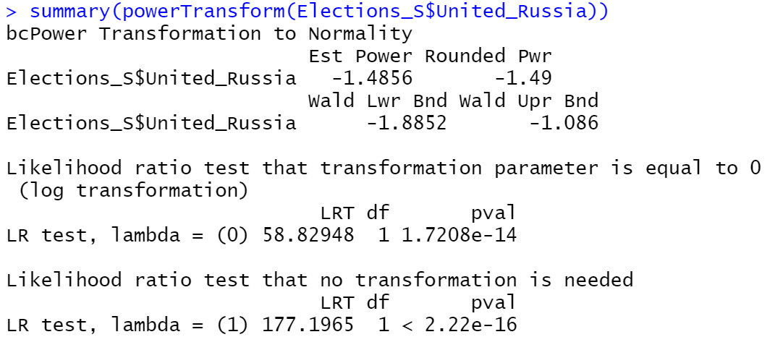

7. Plot indicating the results of the test for linearity.

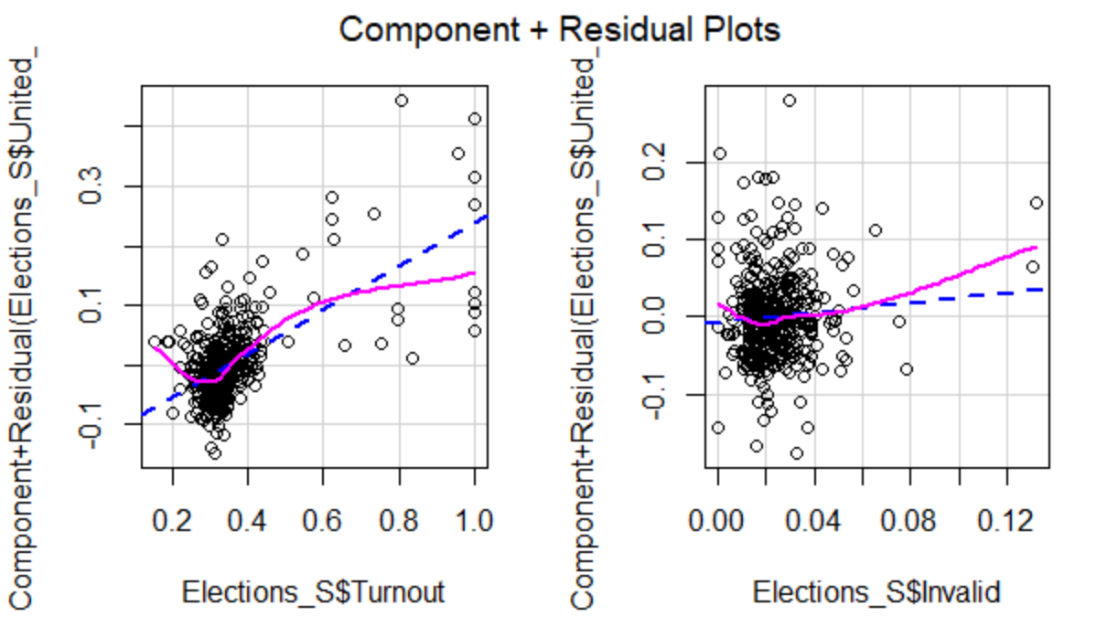

It is apparent that the relationship is not linear because the pink line doesn’t fully correspond with the blue dashed one.

Thus, I did a BoxTidwell transformation.

